Budget Codes
When processing an expense, there are multiple codes for a single transaction. Understanding what the codes mean and when/how to use them will allow you to process any expense correctly.
Every year the Budget Unit posts to the DNR Intranet an updated list of available codes for the new fiscal year.
https://dnrintranet.org/ad/budget {Administrative Services tab/ Budget}

Forms, Codes, etc.

FY2020 Department and Project Codes
FY2020 Class, Account and Subaccount List

The Department and Project Codes list provides the string of codes you will need for your site. There is a separate list for each Division within DNR.

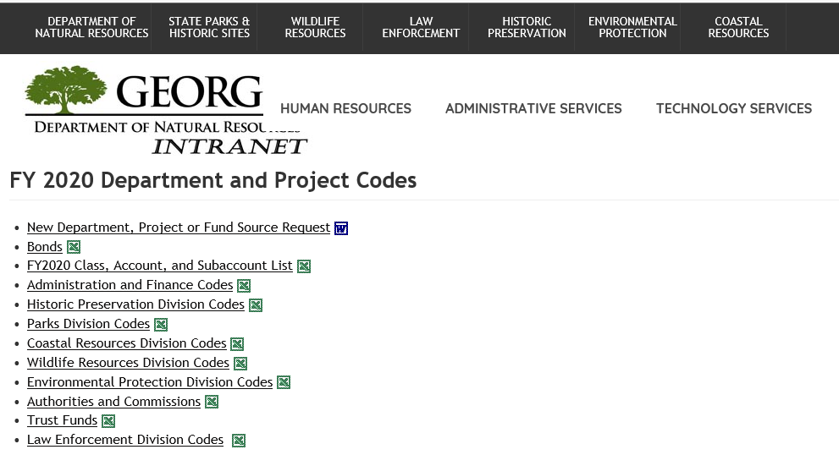

The spreadsheet for Parks Division has a tab per Region as well as Headquarters and ParkPass. Region tabs begin with 43=Field Operations followed by Region number, EX: R1= 431.

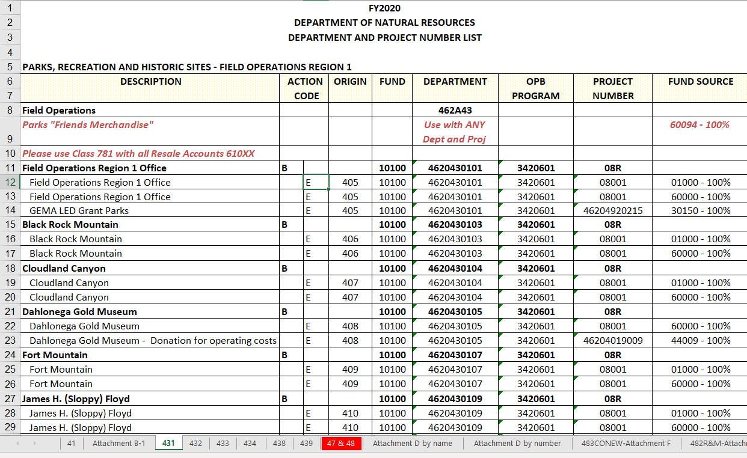

Here is a SAMPLE of Standard Park Budget Codes
FY2020
DEPARTMENT OF NATURAL RESOURCES
DEPARTMENT AND PROJECT NUMBER LIST
DESCRIPTION | ACTION |  | ORIGIN | FUND | DEPARTMENT | OPB | PROJECT | FUND SOURCE
 | CODE |  |  |  |  | PROGRAM | NUMBER
Field Operations Region 1 Office |  | E | 405 | 10100 | 4620430101 | 3420601 | 08001 | 60000
Definitions:
E= Expense
Origin= Unique 3-digit code representing your site. PeopleSoft automatically assigns this number when creating PO’s. 1 default number per Buyer. You can search for existing PO numbers for your park by origin number.
Fund and OPB Program remain the same for park budget transactions which are F=10100 and Program=3420601
Department Number: Every park, historic site, region office or unit is assigned a unique 10-digit number. 4620430 is standard for Field Operations, followed by your region number {1,2,3 or 4} and last 2 digits identify your specific park.
Project: 08001= State Funds Typical routine expense for a Park will be charged to 08001. However,
other Project Numbers maybe assigned for tracking purposes. Operations
may allocate Programming or Volunteer funds which will have their own
project numbers. ParkPass is another example…see below

Fund Sources: 60000= Revenue 01000=State Funds Most parks will default to 60000 when processing
payments. You may see Personal Services post to
State Funds when reconciling your budget.

NOTE: Parks "Friends Merchandise", Use with ANY Dept and Project number, Fund Source 60094
Parks fund source and product should be the same

Here is a SAMPLE: Standard ParkPass Codes---see Tab 438 for full list of project numbers

DESCRIPTION | FUND | DEPARTMENT | OPB | PROJECT | FUND SOURCE | CLASS
 |  |  | PROGRAM | NUMBER
ParkPass | 10100 | 4620430800 | 3420601 | Varies- see chart | 65000 | 801

For ParkPass, All of the above codes are standard for every transaction only the Project number may change.
Class = 801 no matter the account code. Fund Source= 65000 designates the funds as ParkPass
ParkPass has multiple project numbers associated with this department number for budgetary tracking purposes depending on the type of project/scope of work. Your Regional Office has PP funds and then Operations distributes funds for HVAC, Flooring, Roofing, etc. Each of these buckets of funds will have a unique project number so it is critical that you make sure you are using the right one for the work you are processing an expense for.
NOTE: 08001 is NOT a valid project number for ParkPass. 60000 is NOT a valid FS for Parkpass.
The Final Codes you will need describe the type of product. Is this a general supply item, vehicle parts, registration fee, service work, repair job, rental fees, etc.?

The Class, Account and Subaccount list provides the Account and Class defining the type of product.
FY2020 Class, Account and Subaccount List

Class 300= Personal Services- Salary and Part-time employee expenses
Class 301= Regular Operating Expenses which is where most of the park expenses will fall
Class 801= ParkPass expenses----use any account code but always use class 801
Class 781= Retail Merchandise for Sale
{these are only a few of the classes….review the list to see all the available classes and accounts}

When coding an expense, you also have to select an appropriate account code. Do Not use the account code ending in 000 but instead use the subaccount numbers which further define the expense. Ex: Vehicle Expense is the account/category 612000, but when expensing parts, you would list account 612004.
CLASS 301 - REGULAR OPERATING EXPENSES

Cls Account
301 | 611000 | POSTAGE
301 | 611001 | Postage
301 | 611002 | Postage Meter
301 | 611003 | Permit
301 | 611004 | Mail / Express
301 | 611200 | Market Bulletin Postage
301 | 612000 | MOTOR VEHICLE EXPENSE
301 | 612001 | MV Expense - Gasoline
301 | 612002 | MVE-Oil, Grease & Fluids
301 | 612003 | MV Exp-Vehicle Repairs & Maint
301 | 612004 | MV Expenses - Parts & Supplies
301 | 612005 | MV Expenses - Aviation Fuel
301 | 612006 | MV Expenses - Diesel
301 | 612007 | MV Expenses - Natural Gas
301 | 612008 | MVE-Tags & Titles
301 | 612009 | MV Expenses - Inspection Fees
301 | 612010 | MVE-DOAS Vehicle Program
301 | 612012 | Motor Vehicle Exp - Propane
**this is only a sample—review the list for all accounts available
For ParkPass, use Class 801 with any account code

For Retail Merchandise for Sale, use Class 781 with all Retail {Resale} Accounts 6100XX
CLASS 781 - COST OF GOODS SOLD/PURCHASES FOR RESALE
Cost of Goods Sold/Purchases for Resale | 610000
Cost of Goods Sold/Purchases for Resale | 610001
Merchandise for Resale - Restaurant | 610050
Merchandise for Resale - General | 610060
Merchandise for Resale - Golf Course | 610070
Merchandise for Resale - Nonfood | 610071
Merchandise for Resale - Gasoline | 610072
Merchandise for Resale - Alcohol & Beverages (For Lodge Use Only) | 610073

So let’s review and see how codes are used to complete a voucher.
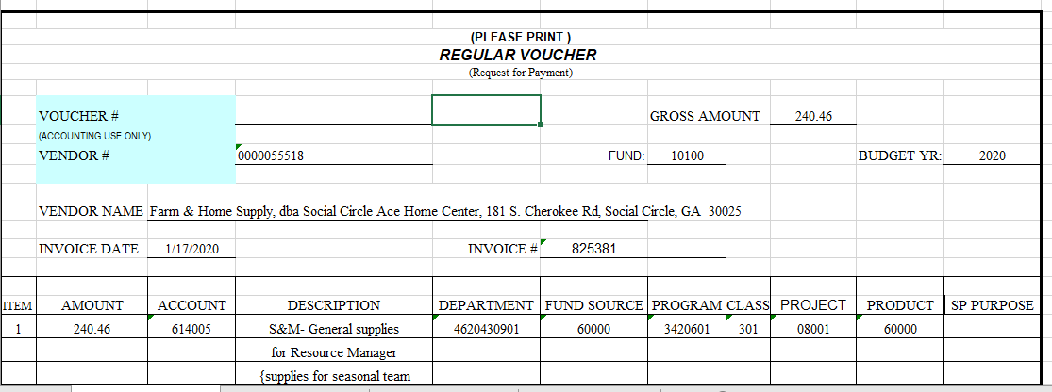
Fund will always be 10100. Account 614005 for General Supplies & materials. Then fill in your department number, Fund Source of 60000 for revenue, program of 3420601, Class 301 to match 614005 for your department budget, project 08001 for regular state funds and then Product----product will generally match your Fund Source unless this is a special expense that Accounting stipulates should have a different product number. In this example, your product will be same 60000 for revenue.
For ParkPass, the department number will always be 4620430800, the Fund Source will always be 65000, the program will always be 3420601, the Product will always be the same as the Fund Source 65000 and the class will always be 801. The project number will vary depending on what is being funded.

